Task # 1:

Create the following spreadsheet in Microsoft Excel and be sure to use formulas to calculate the following:

1. The total number of games played under the column labelled GP. The total number of games played can be calculated by adding total wins (W), total losses (L) and total overtime losses (OTL).
2. The goal differential under the column labelled DIFF. The goal differential can be calculated by subtracting the goals for (GF) and the goals against (GA).

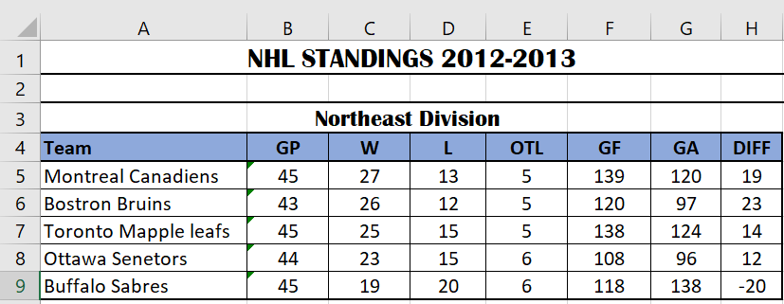

Task # 2:

Create the following spreadsheet in Microsoft Excel and be sure to use formulas to calculate the following:

1. Each employee’s gross pay under the column labelled GROSS PAY. An employee’s gross pay can be calculated by multiplying the hours worked by the hourly wage.
2. The amount of tax paid under the column labelled TAXES. Taxes are calculated by taking 35% of the gross pay.
3. The net pay under the column labelled NET PAY, which is calculated by subtracting the taxes from the gross pay.
4. The totals of the last three columns (cells D12, E12, and F12).

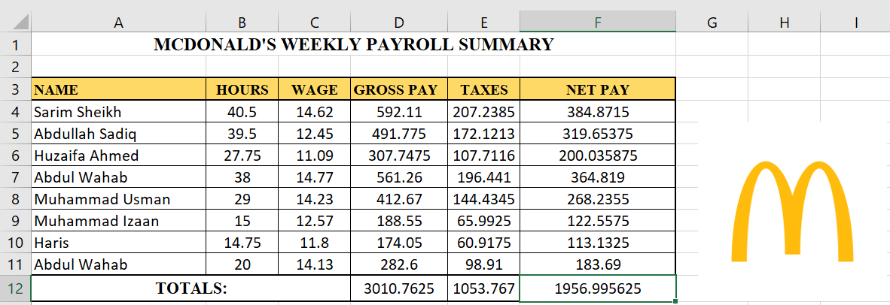

Task # 3:

Create the following spreadsheet in Microsoft Excel and be sure to use formulas to calculate the following:

1. Each student’s overall average (H3 to H11) by adding the marks on each student’s assignments and tests and dividing it by 6. Be sure to use the AVERAGE function.
2. The class average for each assignment and test (B12 to G12).
3. The class median for each assignment and test (B13 to G13). Use the MEAN function.
4. The highest mark for each assignment and test (B14 to G14). Use the MAX function.
5. The lowest mark for each assignment and test (B15 to G15). Use the MIN function.
6. The overall class average (H12), the overall class median (H13), the overall highest mark in the

class (H14), and the overall lowest mark in the class (H15).

